St. Francis Institute of Technology, Mumbai-400 103

**Department Of Information Technology**

A.Y. 2024-2025

Class: TE-ITA/B, Semester: VI

Subject: **Business Intelligence Lab**

**Experiment – 10: Study and application of open source BI tool (Qlikview, Tableau, Pentaho, Rapid Miner)**

1. **Aim:** Study and application of open source BI tool (Qlikview, Tableau, Pentaho, Rapid Miner)
2. **Objectives:** After study of this experiment, the students will be able to know different BI Tools
3. **Outcomes:**

**CO6:**Apply BI to solve practical problems : Analyze the problem domain, use the data collected in enterprise apply the appropriate data mining technique, interpret and visualize the results and provide decision support

1. **Prerequisite:** Introduction to all Open Source BI tools.
2. **Requirements:** Personal Computer, Windows XP /Windows 7/8 operating system, Internet Connection, Microsoft Word.
3. **Theory:**
4. **What is BI**

**ANS:** Business Intelligence (BI) refers to technologies, processes, and tools that help organizations analyze business data.

1. It enables data-driven decision-making by transforming raw data into meaningful insights.
2. BI involves data collection, storage, processing, and visualization for better business understanding.
3. It includes tools like dashboards, reports, data warehouses, and analytics software.
4. BI helps in identifying trends, patterns, and correlations in business operations.
5. It combines historical and real-time data for comprehensive analysis.
6. BI solutions use techniques like data mining, predictive analytics, and machine learning.
7. Organizations use BI to optimize processes, increase efficiency, and reduce costs.
8. It enhances strategic planning, sales forecasting, and customer relationship management.

**2. Need of BI**

**ANS**

1. Helps businesses make informed, data-driven decisions for growth.
2. Identifies inefficiencies and areas of improvement in operations.
3. Enhances customer insights by analyzing buying behavior and preferences.
4. Supports real-time monitoring of key performance indicators (KPIs).
5. Aids in risk management by detecting fraud and anomalies in data.
6. Optimizes resource allocation and financial planning.
7. Improves market analysis and competitive benchmarking.
8. Increases operational efficiency by automating reporting processes.

**3. Applications of BI**

**ANS:**

1. Sales & Marketing: Tracks customer behavior, sales trends, and campaign effectiveness.
2. Finance & Accounting: Analyzes financial performance, fraud detection, and budgeting.
3. Healthcare: Improves patient care, hospital management, and predictive diagnostics.
4. Retail & E-commerce: Enhances inventory management, demand forecasting, and personalized recommendations.
5. Supply Chain & Logistics: Optimizes transportation, warehouse management, and demand-supply balancing.
6. Manufacturing: Enhances production planning, quality control, and equipment maintenance.
7. Government & Public Sector: Aids in policy-making, fraud prevention, and public service efficiency.
8. Education: Tracks student performance, resource allocation, and institutional analytics.
9. Human Resources: Improves talent acquisition, employee performance analysis, and workforce planning.
10. **List Tools of BI**

**ANS:**

1. **Power BI** – Microsoft’s data visualization and analytics tool.
2. **Tableau** – Interactive data visualization and business intelligence platform.
3. **Qlik Sense** – Self-service BI tool with AI-driven insights.
4. **Looker** – Cloud-based BI tool for data exploration.
5. **Domo** – Cloud BI platform for real-time data analysis.
6. **SAP BusinessObjects** – Enterprise BI suite for reporting and analytics.
7. **IBM Cognos Analytics** – AI-powered BI and data visualization tool.
8. **Sisense** – BI platform with embedded analytics and AI integration.
9. **MicroStrategy** – Enterprise analytics and mobility BI tool.
10. **Google Data Studio** – Free data visualization and reporting tool.
11. **Zoho Analytics** – Self-service BI and analytics platform.

**k. Elaborate on Pentaho, Rapid Miner, Qlikview, Tableau**

* **Features**
* **Data Set required**
* **Working**
* **Advantages**
* **Limitations**
* **Applications**

**ANS:**

| **Feature** | **Pentaho** | **Rapid Miner** | **Qlikview** | **Tableau** |
| --- | --- | --- | --- | --- |
| **Type** | BI & Data Integration | Data Science & Machine Learning | BI & Data Visualization | BI & Data Visualization |
| **Data Preprocessing** | ETL, OLAP, and Reporting | Predictive Analytics & ML | In-memory data processing | Interactive dashboards |
| **Deployment** | On-premise & Cloud | On-premise & Cloud | On-premise & Cloud | On-premise & Cloud |
| **User-Friendliness** | Moderate | Complex (for beginners) | Complex (for beginners) | Highly user-friendly |
| **Integration** | Supports multiple databases & big data tools | Works well with ML libraries | Integrates with multiple data sources | Supports various data sources |

1. **Laboratory Exercise:** Attach screenshots for tableau and Qlikview using sample dataset
2. **Post-Experiments Exercise**
3. **Questions:**
   * Compare and Contrast between Qlikview and Tableau
4. **Conclusion:**
   * Summary of Experiment
   * Importance of Experiment
   * Application of Experiment

1. **Reference:** Business Intelligence: Data Mining and Optimization for Decision Making by Carlo Vercellis, Wiley India Publications

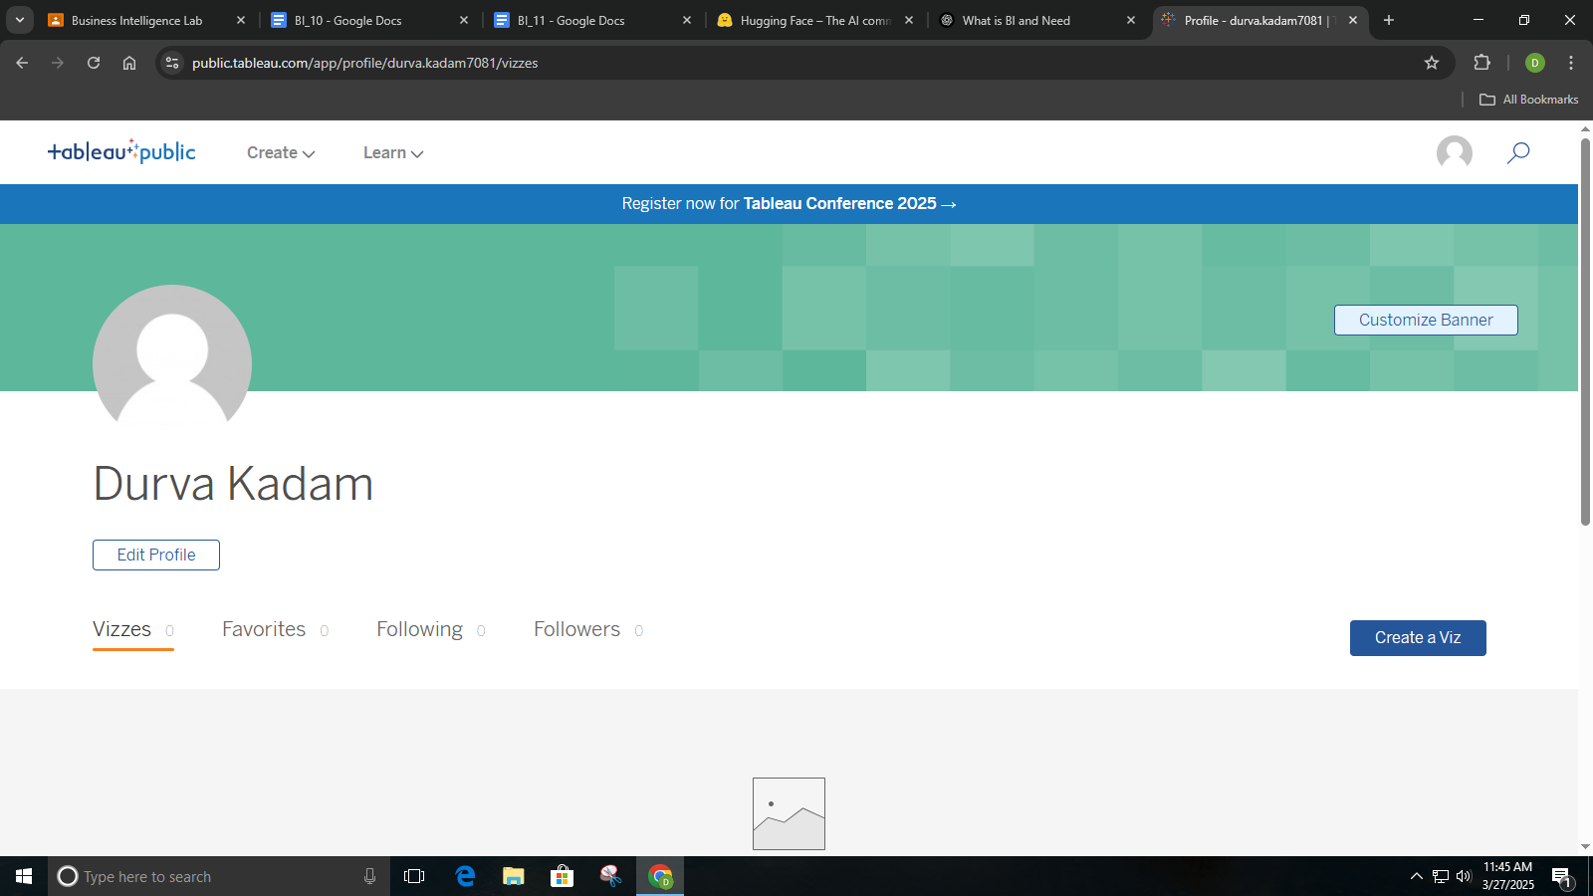

Downloading Superstore dataset from tableau public.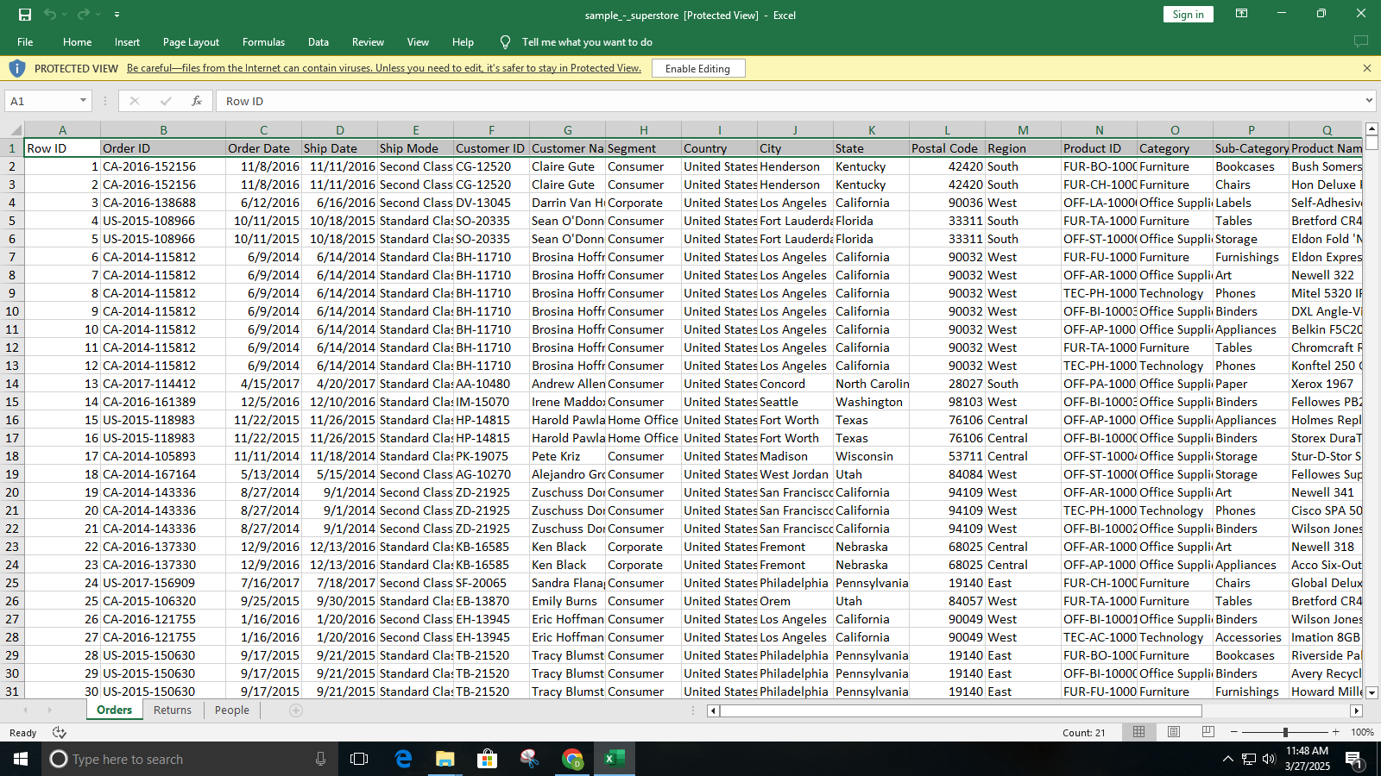

Uploading the orders sheet in Tableau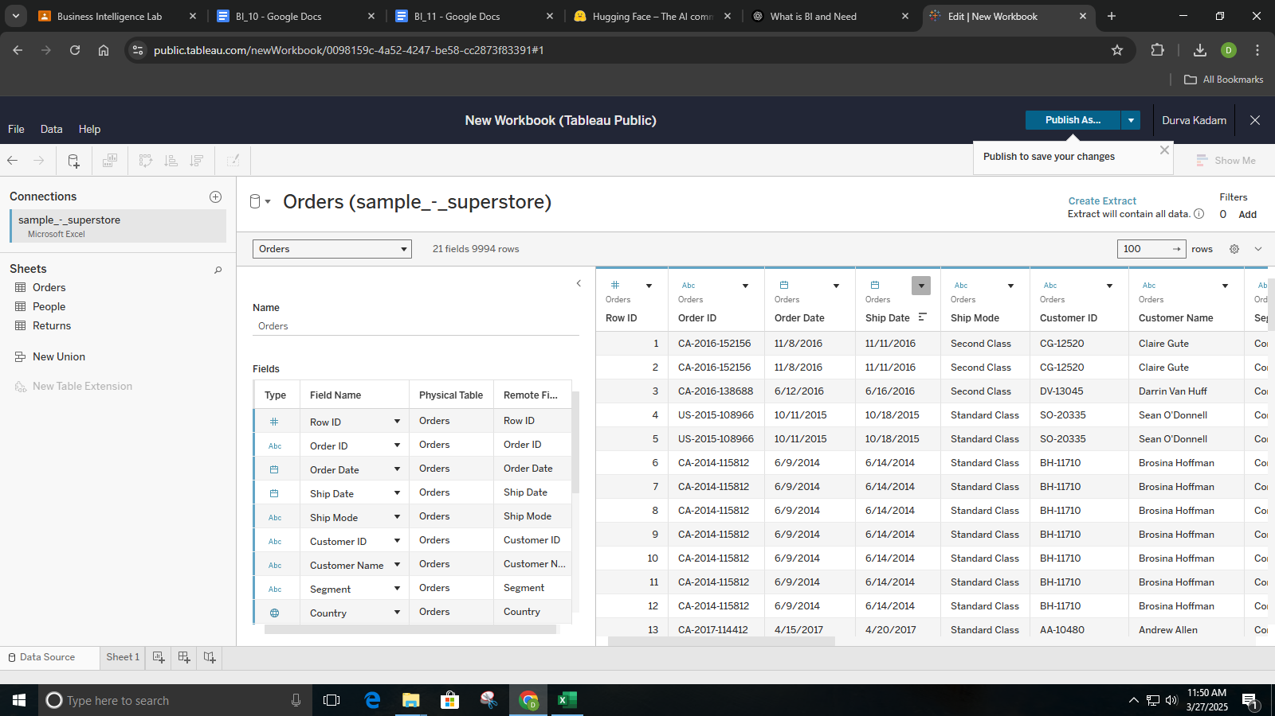

WE created a separate sheet with category as column and region as row and showed the sum of sales in the table.

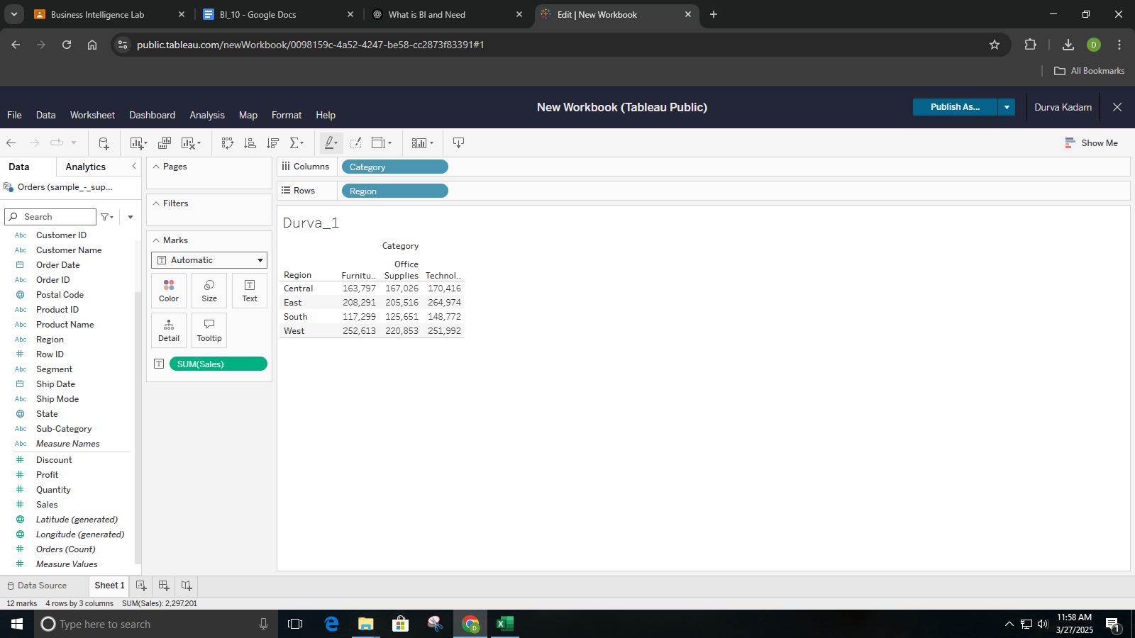

I added YEAR as a filter to show data from 2014-2018 and placed it in the Filters shelf. Then, I dragged YEARand SUM(Sales) to the Columns shelf and Category & Region to the Rows shelf for detailed grouping. 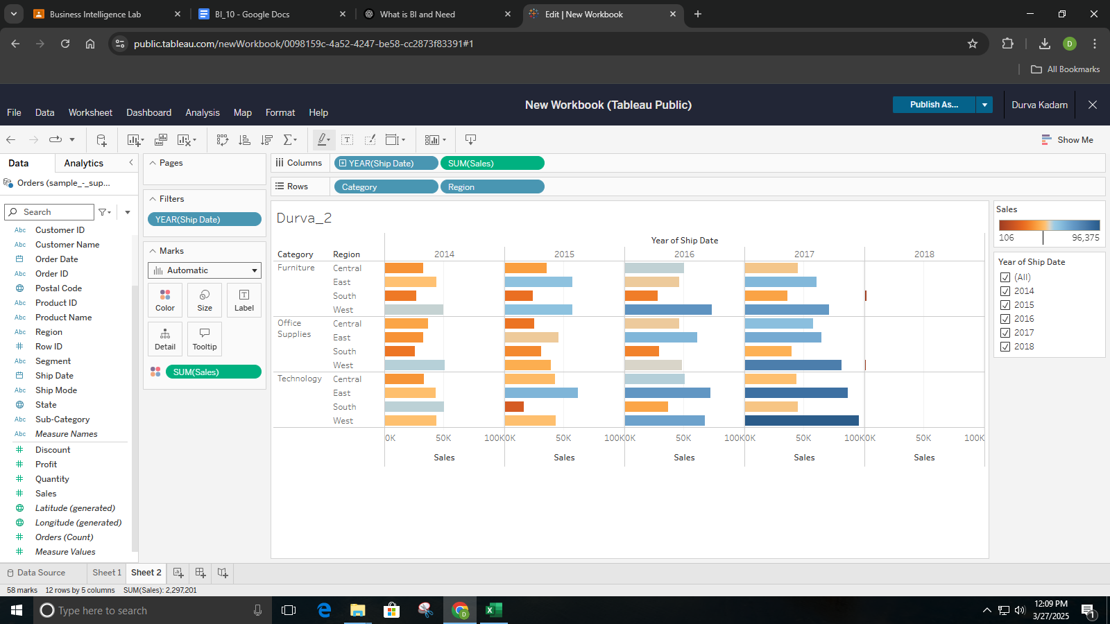

I added Region to the Columns shelf and SUM(Sales) to the Rows shelf to create a box plot. Then, I dragged Sub-Category to the Marks section to represent data points as circles.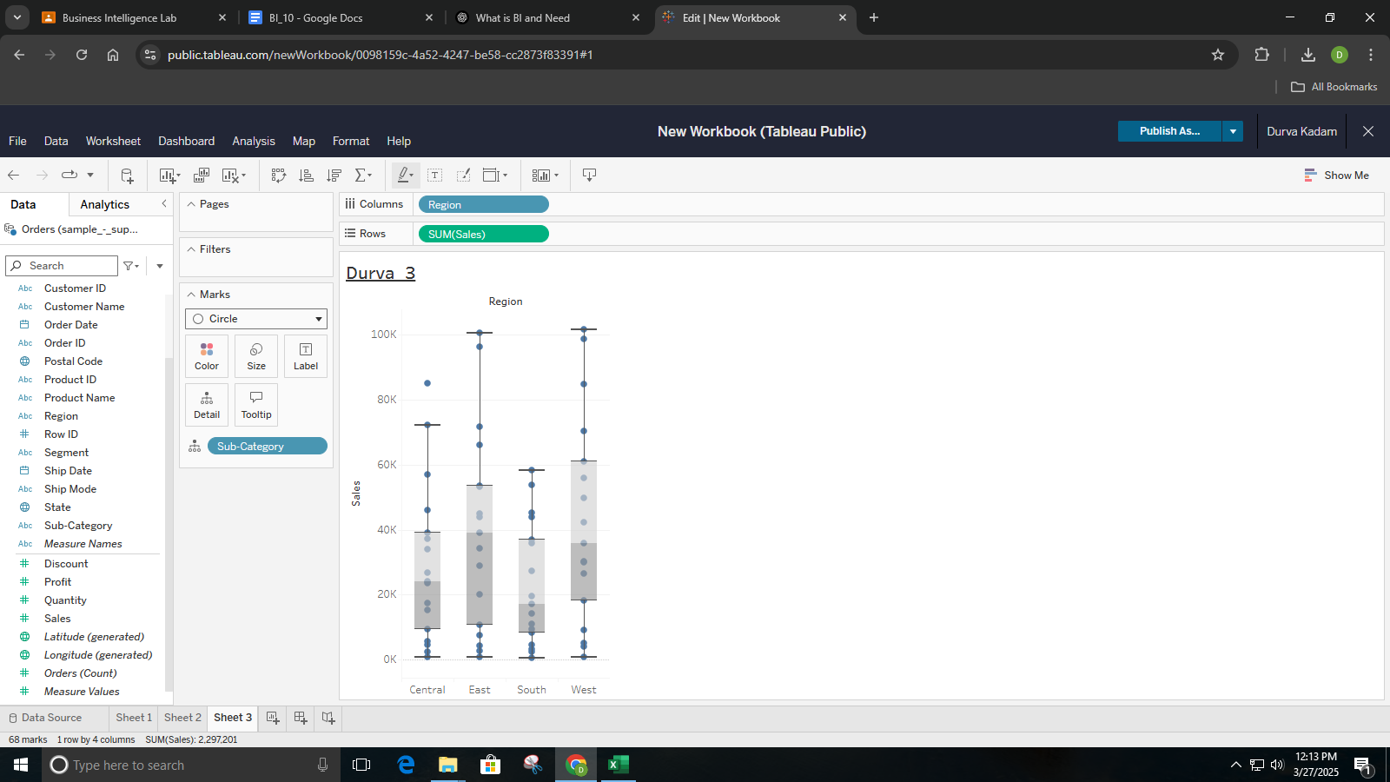

| Creating Dashboard | Creating story in Tableau |
| --- | --- |

Published the story on Tableau

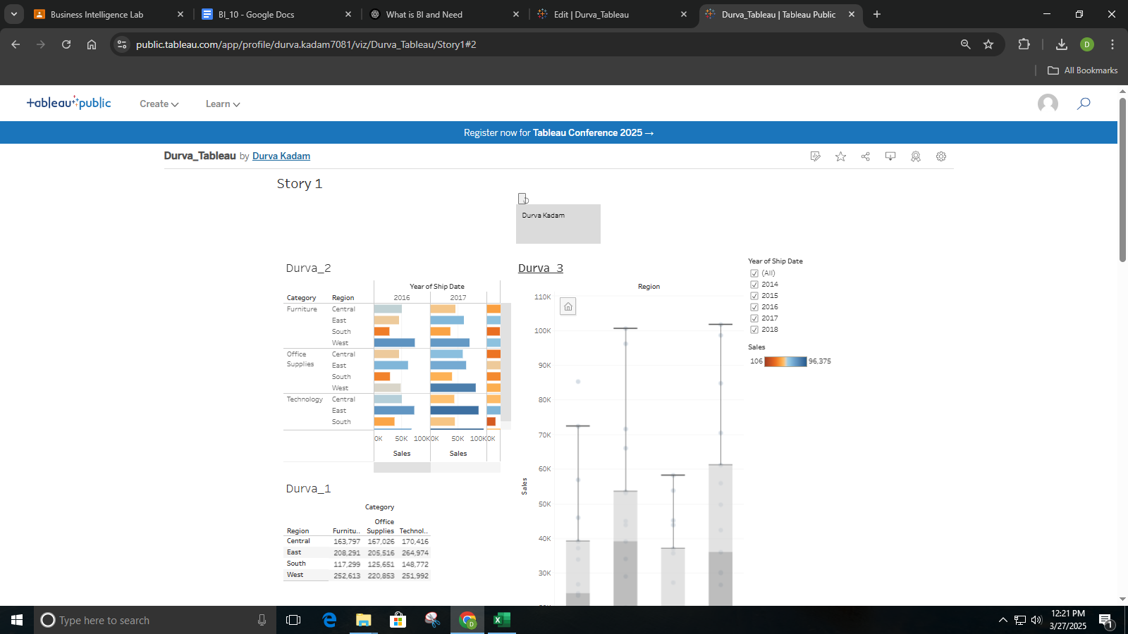

This QlikView dashboard visualizes sales data using interactive charts. It includes bar, line, pie, and box plots to analyze sales by region and category. The tool helps in business intelligence and decision-making through data visualization.

